**CAPSTONE PROJECT REPORT**

**TEAM MEMBERS:** Shaik.Nayaz Irfan Ali, Sirigiri.Mahesh Kumar

**REGISTER NO:** 192211326 ,192211328

**COURSE CODE:** CSA0541

**NAME:** Database Management Systems for Designing

**PROJECT TITLE**

**Airport Database Management System**

**OBJECTIVE**

The primary objective of the Airport Management System is to develop a comprehensive and user-friendly platform designed to streamline and improve airport operations. This system aims to enhance the efficiency of airport management tasks, including flight scheduling, passenger processing, luggage handling, and airport security management. By integrating advanced technologies and a Database Management System (DBMS), the goal is to provide a seamless and efficient experience for both airport staff and travelers. The focus will be on optimizing operational flow, improving safety and security measures, and ensuring timely and accurate information is available to all stakeholders, thereby elevating the overall quality of airport services and passenger satisfaction.

**GANTT CHART**

For the Airport Database Management System project outlined in the Gantt chart from February 6, 2024, to March 20, 2024, the following literature provides foundational knowledge and innovative insights into the development and enhancement of such systems

|  |  |  |  |  |  |  |  |  |  |
| --- | --- | --- | --- | --- | --- | --- | --- | --- | --- |
| DURATION / TASK | 06-02-2024  08-02-2024 | 10-02-2024  15-02-2024 | 16-02-2024  20-02-2024 | 21-02-2024  24-02-2024 | 25-02-2024  29-02-2024 | 01-03-2024  06-03-2024 | 07-03-2024  14-03-2024 | 15-03-2024  19-03-2024 | 20-03-2024 |
| LITERATURE SURVEY |  |  |  |  |  |  |  |  |  |
| REQURIMENT ANALYSIS |  |  |  |  |  |  |  |  |  |
| DATABASE DESIGN |  |  |  |  |  |  |  |  |  |
| FRONTEND DEVELOPMENT |  |  |  |  |  |  |  |  |  |
| BACKEND DEVELOPMENT |  |  |  |  |  |  |  |  |  |
| INTEGRATED TESTING |  |  |  |  |  |  |  |  |  |
| USER ACCEPTANCE TESTING |  |  |  |  |  |  |  |  |  |
| DEMO |  |  |  |  |  |  |  |  |  |
| PRESENTATION |  |  |  |  |  |  |  |  |  |

**INTRODUCTION**

An Airport Database Management System (DBMS) is a sophisticated technology solution designed to revolutionize the way airports operate, ensuring efficient, secure, and seamless airport management. At the core of this system lies the integration and optimization of all airport-related data, from flight schedules and passenger information to baggage tracking and staff allocation. This introduction aims to outline the system's significance, its primary objectives, and the value it brings to modern airport operations.

In today's fast-paced and security-sensitive environment, airports face the challenge of managing vast amounts of data across various operations efficiently. The introduction of a DBMS addresses these challenges head-on, providing a centralized platform that not only stores and manages data but also facilitates real-time decision-making and operational efficiency. This is essential for enhancing airport security, a top priority for airport authorities, by enabling the monitoring and management of security measures, access controls, and emergency responses through real-time data access.

Moreover, the system places a strong emphasis on improving the passenger experience. By streamlining processes such as check-ins, flight updates, and baggage handling, the DBMS aims to minimize delays and inconveniences, thereby enhancing passenger satisfaction. This focus on the passenger experience is critical in an era where customer satisfaction is paramount to an airport's success and reputation.

Real-time data integration is like having a live feed straight from the heart of your airport. It seamlessly connects your database to constantly flowing information, giving you a real-time pulse of everything happening - from flight locations to security wait times. This translates to better decision-making, smoother operations, and ultimately, happier passengers.

**SCOPE OF THE PROJECT**

The scope of the Airport Database Management System (ADMS) project encompasses several key areas designed to revolutionize the operational, security, and passenger experience aspects of airport management. Through the integration of state-of-the-art database technologies and innovative data management practices, the project aims to deliver a comprehensive solution that addresses the complex needs of modern airports.

**EXISTING SYSTEM**

The existing system of an Airport Database Management System (ADMS) typically refers to the comprehensive software and hardware solutions used to manage and monitor all aspects of an airport's operations. This includes a wide array of functionalities, from passenger processing, baggage handling, and flight operations to security, maintenance, and commercial services. While specific implementations can vary significantly from one airport to another, most ADMS share several core components and characteristics

**PROPOSED SYSTEM**

Real-time data integration in an airport database management system (DBMS) involves seamlessly combining live data feeds from various sources within the airport with the existing database. This creates a constantly updated picture of airport operations, allowing for more informed decision-making and a significantly improved passenger experience.

**FEATURES**

* **Continuous Data Flow**
* **Dynamic Update**
* **Streamlined Passenger Experience**
* **Improved Data Accuracy**

**BENEFITS**

* Enhanced Situational Awareness
* Improved Passenger Experience
* Optimized Resource Allocation
* Predictive Analytics

**APPLICATIONS**

* Flight Tracking.
* Weather Monitoring
* Security Wait Times
* Baggage Handling

**HARDWARE REQUIREMENTS**

* Processor: Any new generation processor
* RAM: Reasonable for the processor
* Hard Disk Drive: More than 512 MB
* Key Board: Standard Keyboard
* Monitor: Any color monitors
* Display Adapters: Super Video Graphics Array (VGA)
* Mouse: Optical mouse

**SOFTWARE REQUIREMENTS**

* Operating System supports Windows 10
* CSHARP(C#)
* SOL Server 2017
* Microsoft Visual Studio 2017

**SQL**- (STANDARDIZED QUERY LANGUAGE)

**ENTITY RELATIONSHIP DIAGRAM**

An Entity Relationship Diagram (ERD) is a graphical tool to express the overall structure of a

database. It is based on a perception of a real world which consists of a set of basic objects. An

entity is a person, place, thong or event of interest to the organization and about which data are

captured, stored or processed. The attributes are various kinds of data that describes an entity. An association of several entities in an Entity-Relationship model is called relationship

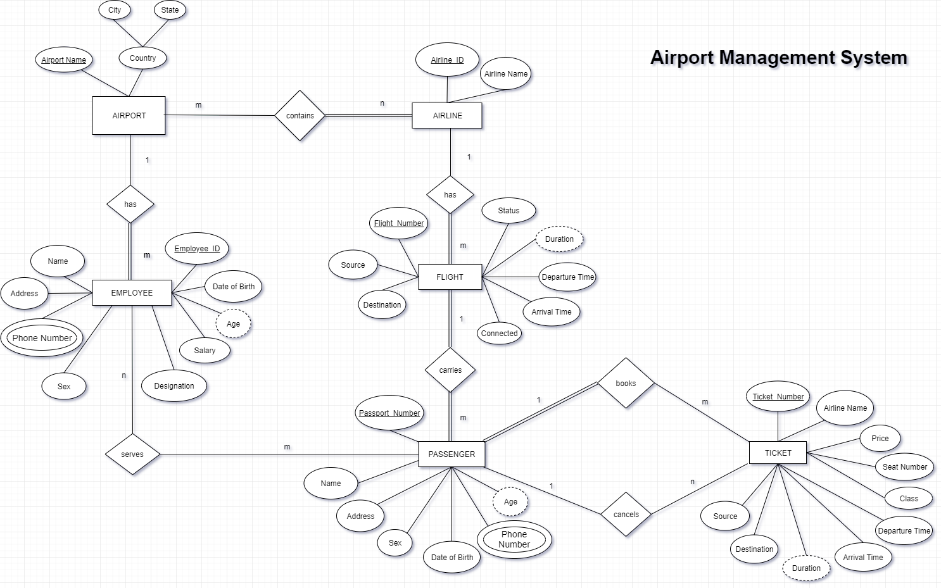

**RELATIONAL SCHEMA**

A relational schema is a data model that represents the structure of a database, including the tables and related items that make up the database. A relational schema includes the following components

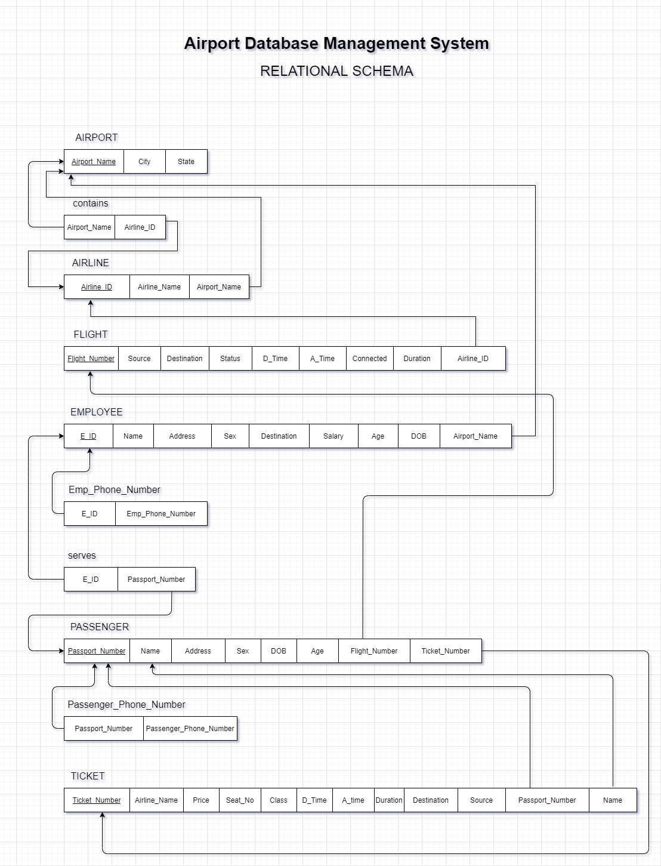

**The Implementation requires the following tasks**

* Careful planning.
* Investigation of the system and constraints.
* Design of methods to achieve the changeover.
* Evaluation of changeover method

## **FUTURE ENHANCEMENT**

While real-time data integration offers a significant leap forward, consider these future enhancements to push your airport DBMS to even greater heights:

**Advanced Data Analytics:** Don't just collect data – unlock its hidden potential! Implement advanced data analytics tools to delve deeper into passenger flow patterns, resource utilization, and potential bottlenecks. This empowers you to optimize airport operations, streamline resource allocation, and identify areas for improvement on a deeper level.

**Mobile App Integration:** Imagine a mobile app that acts as a personal assistant for passengers navigating the airport. Integrate your real-time data with a mobile app that allows passengers to track their flights, navigate the airport efficiently, and access important updates directly on their mobile devices. This seamless integration would significantly enhance passenger convenience and satisfaction.

**Biometric Integration (Consider Ethical Implications):** Explore the possibilities of integrating biometric identification systems for passengers. Facial recognition or fingerprint scanners could streamline check-in processes and security clearances, further enhancing passenger experience. However, remember to carefully consider the ethical implications and data privacy concerns before implementing this feature.

**CONCLUSION**

Real-time data empowers airport staff with unparalleled situational awareness. They can monitor flight locations, security wait times, or baggage handling progress in real-time, allowing for proactive responses to disruptions, delays, or unforeseen circumstances. Passengers, too, benefit immensely. Real-time updates on flight status, gate changes, baggage claim locations, and security wait times reduce stress, allow for better trip planning, and ultimately improve the overall passenger experience. Additionally, real-time data analysis allows for resource allocation optimization. Security personnel can be redeployed based on passenger flow, ensuring efficient queuing management. Furthermore, predictive analytics become possible. By analyzing real-time and historical data, the system can predict potential problems like delays or congestion, enabling proactive measures like pre-emptive communication with passengers or rerouting resources.

**LITERATURE SURVEY:**

**1."Integrating AI in Airport Operations" by James O'Connor**Investigates the application of Artificial Intelligence (AI) in enhancing airport operational efficiency, safety, and passenger experience, including predictive analytics for flight delays and facial recognition for security.

**2."IoT Solutions for Smart Airports" by Anita Sharma**Discusses the deployment of Internet of Things (IoT) technologies in airports for real-time tracking, energy management, and maintenance monitoring, contributing to the development of smart airports.

**3."Blockchain in Aviation: Opportunities and Challenges" by Henry Liu**Explores the potential of blockchain technology in revolutionizing information sharing, security, and transparency within the aviation industry, with a focus on ticketing, cargo, and identity verification.

**4."Leveraging Big Data for Airport Management" by Maria Gonzalez**Examines the role of big data analytics in optimizing airport operations, improving passenger flow, and forecasting traffic, highlighting the importance of data-driven decision-making.

**5."Cloud Computing: Transforming Airport Database Systems" by Kevin Patel**Outlines the benefits and implementation strategies of cloud computing in airports, emphasizing scalability, data accessibility, and collaborative efficiency across stakeholders.

**6."Facial Recognition Technology for Airport Security" by Sarah Kim**Analyzes the application and implications of facial recognition technology in enhancing airport security measures, including its integration with database management systems for identity verification.

**7."Sustainable Practices in Airport Operations" by Laura Thompson**Reviews sustainable practices and technologies in airport operations, focusing on the use of data analytics and IoT to minimize environmental impact and promote efficient resource use.

**8."Data Sharing and Collaboration in the Aviation Ecosystem" by Alex Johnson**Investigates the significance of secure and efficient data sharing among aviation stakeholders, with an emphasis on the role of blockchain and cloud solutions in fostering collaboration.

**9."User Experience Design in Airport Systems" by Rachel Lee**Discusses principles and case studies related to the design of user-friendly interfaces for airport systems, ensuring an intuitive and efficient user journey from check-in to boarding.

**10."Operational Resilience in Airports Through Advanced DBMS" by Michael Chen**Explores strategies for enhancing operational resilience in airports, including disaster recovery and business continuity planning facilitated by advanced database management systems.